**Initial setup checks:**

PS C:\Udacity Nano Degree\Assignment 3> kubectl get pods

NAME READY STATUS RESTARTS AGE

postgresql-5d67b67df5-jwtbv 1/1 Running 0 92s

Connect to databse

PS C:\Udacity Nano Degree\Assignment 3> kubectl exec -it postgresql-5d67b67df5-jwtbv -- bash

root@postgresql-5d67b67df5-jwtbv:/#

root@postgresql-5d67b67df5-jwtbv:/# psql -U jdavidson -d jddatabase

psql (16.4 (Debian 16.4-1.pgdg120+1))

Type "help" for help.

jddatabase=#

jddatabase=# \l

List of databases

Name | Owner | Encoding | Locale Provider | Collate | Ctype | ICU Locale | ICU Rules | Access privileges

------------+-----------+----------+-----------------+------------+------------+------------+-----------+-------------------------

jddatabase | jdavidson | UTF8 | libc | en_US.utf8 | en_US.utf8 | | |

postgres | jdavidson | UTF8 | libc | en_US.utf8 | en_US.utf8 | | |

template0 | jdavidson | UTF8 | libc | en_US.utf8 | en_US.utf8 | | | =c/jdavidson +

| | | | | | | | jdavidson=CTc/jdavidson

template1 | jdavidson | UTF8 | libc | en_US.utf8 | en_US.utf8 | | | =c/jdavidson +

| | | | | | | | jdavidson=CTc/jdavidson

(4 rows)

jddatabase=#

PS C:\Udacity Nano Degree\Assignment 3> kubectl get svc

NAME TYPE CLUSTER-IP EXTERNAL-IP PORT(S) AGE

kubernetes ClusterIP 10.100.0.1 <none> 443/TCP 28m

postgresql-service ClusterIP 10.100.117.226 <none> 5432/TCP 7s

PS C:\Udacity Nano Degree\Assignment 3>

PS C:\Udacity Nano Degree\Assignment 3>

PS C:\Udacity Nano Degree\Assignment 3>

Curl command to database:

C:\Udacity Nano Degree>curl 127.0.0.1:5153/api/reports/daily_usage

{"2023-02-07":40,"2023-02-08":202,"2023-02-09":179,"2023-02-10":158,"2023-02-11":146,"2023-02-12":176,"2023-02-13":196,"2023-02-14":142}

Pipeline to push Focker image into ECR

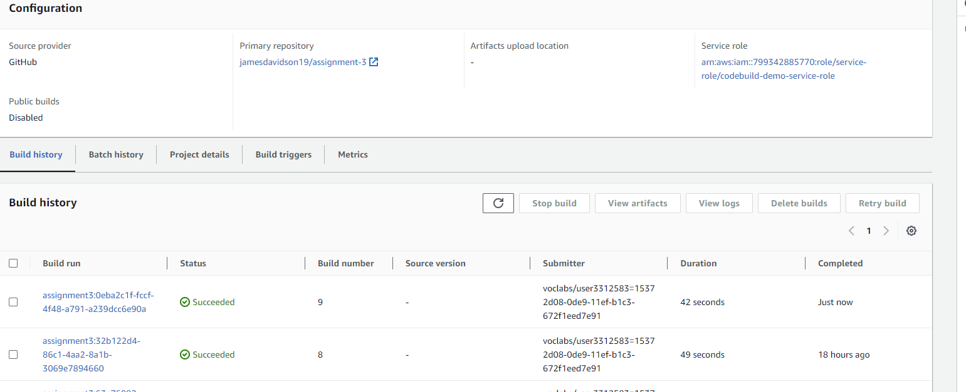

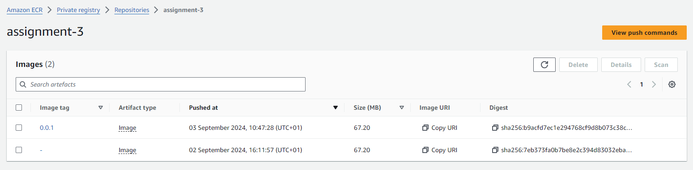

Using Webhook to update

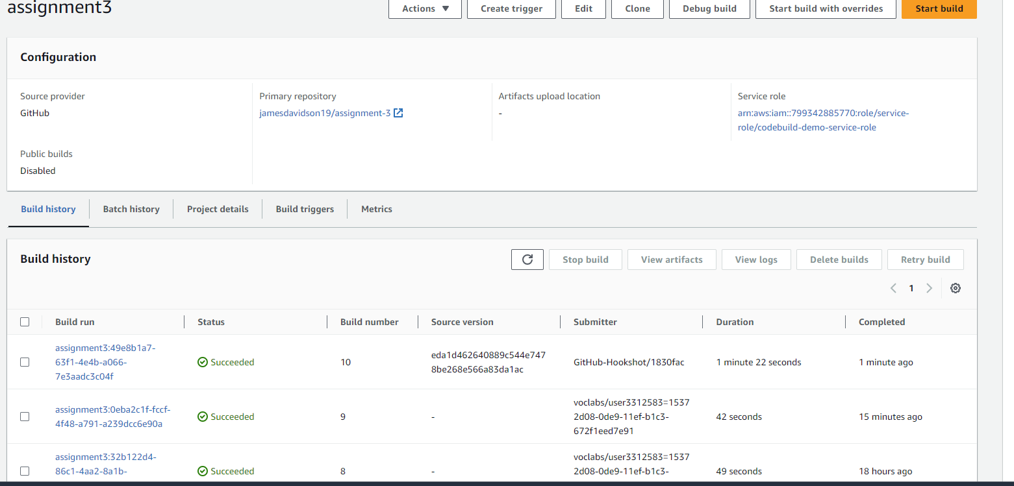

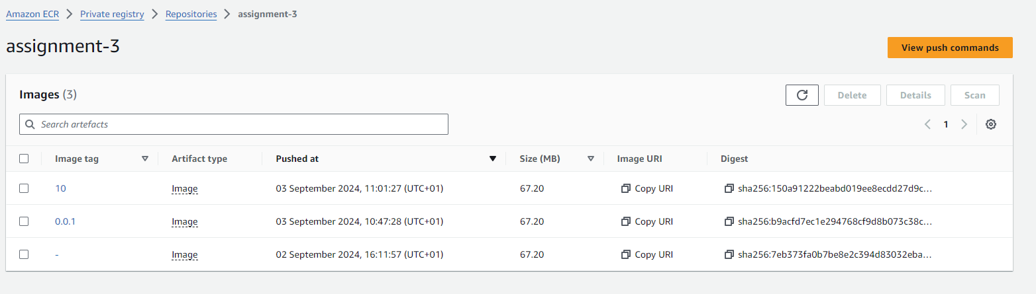

Last run:

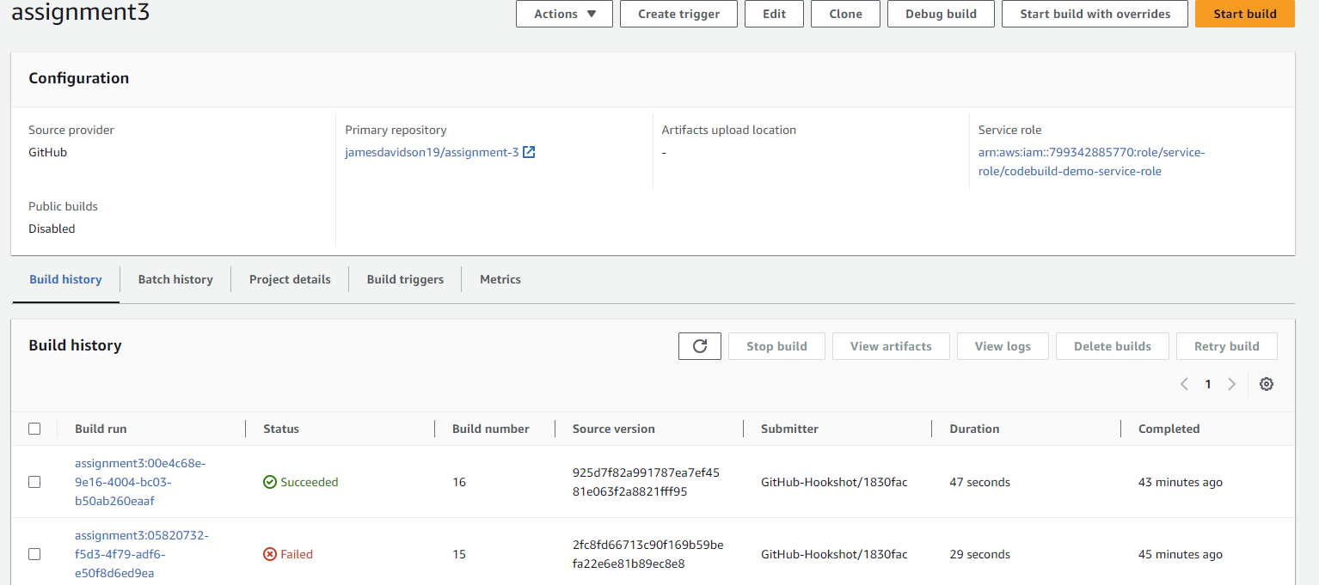

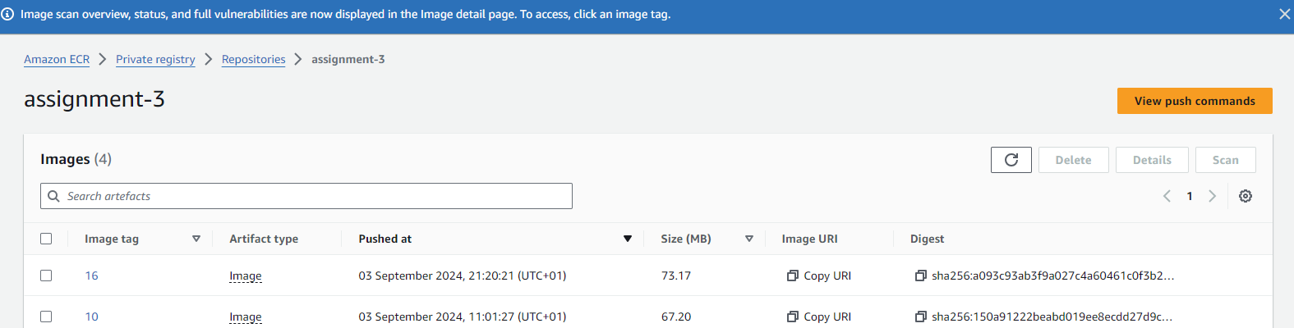

**Kubernettes Outputs**

PS C:\Udacity Nano Degree\Assignment 3> kubectl get svc

NAME TYPE CLUSTER-IP EXTERNAL-IP PORT(S) AGE

kubernetes ClusterIP 10.100.0.1 <none> 443/TCP 91m

postgresql-service ClusterIP 10.100.117.226 <none> 5432/TCP 63m

PS C:\Udacity Nano Degree\Assignment 3>

PS C:\Udacity Nano Degree\Assignment 3>

PS C:\Udacity Nano Degree\Assignment 3> kubectl get pods

NAME READY STATUS RESTARTS AGE

postgresql-5d67b67df5-jwtbv 1/1 Running 0 75m

PS C:\Udacity Nano Degree\Assignment 3>

PS C:\Udacity Nano Degree\Assignment 3>

PS C:\Udacity Nano Degree\Assignment 3> kubectl describe svc postgresql-service

Name: postgresql-service

Namespace: default

Labels: <none>

Annotations: <none>

Selector: app=postgresql

Type: ClusterIP

IP Family Policy: SingleStack

IP Families: IPv4

IP: 10.100.117.226

IPs: 10.100.117.226

Port: <unset> 5432/TCP

TargetPort: 5432/TCP

Endpoints: 192.168.43.17:5432

Session Affinity: None

Events: <none>

PS C:\Udacity Nano Degree\Assignment 3> kubectl describe deployment

Name: postgresql

Namespace: default

CreationTimestamp: Tue, 03 Sep 2024 09:49:35 +0100

Labels: <none>

Annotations: deployment.kubernetes.io/revision: 1

Selector: app=postgresql

Replicas: 1 desired | 1 updated | 1 total | 1 available | 0 unavailable

StrategyType: RollingUpdate

MinReadySeconds: 0

RollingUpdateStrategy: 25% max unavailable, 25% max surge

Pod Template:

Labels: app=postgresql

Containers:

postgresqlkube:

Image: postgres:latest

Port: 5432/TCP

Host Port: 0/TCP

Environment:

POSTGRES_DB: jddatabase

POSTGRES_USER: jdavidson

POSTGRES_PASSWORD: mypassword

Mounts:

/var/lib/postgresql/data from postgresql-storage (rw)

Volumes:

postgresql-storage:

Type: PersistentVolumeClaim (a reference to a PersistentVolumeClaim in the same namespace)

ClaimName: postgresql-pvc

ReadOnly: false

Conditions:

Type Status Reason

---- ------ ------

Available True MinimumReplicasAvailable

Progressing True NewReplicaSetAvailable

OldReplicaSets: <none>

NewReplicaSet: postgresql-5d67b67df5 (1/1 replicas created)

Events: <none>

PS C:\Udacity Nano Degree\Assignment 3>

Secret applied:

kubectl apply -f ./secret.yaml

secret/jddb-secret created

Deployment applied

kubectl apply -f ./deployment.yaml

service/assignment-3 created

deployment.apps/assignment-3 created

**Deployed application screenshots and outputs:**

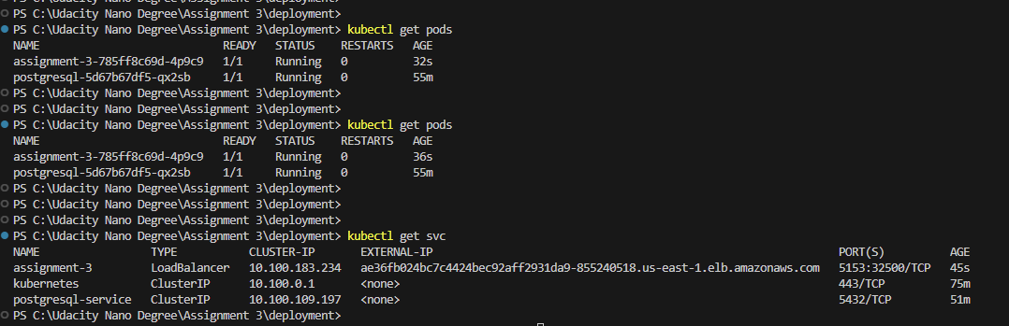

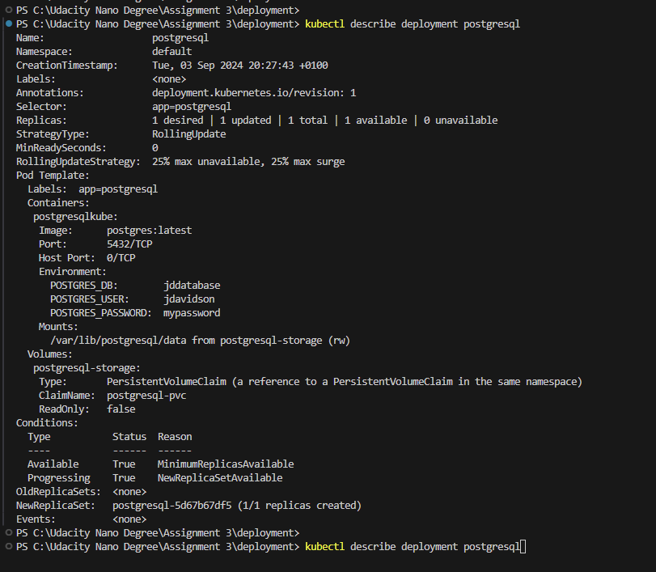

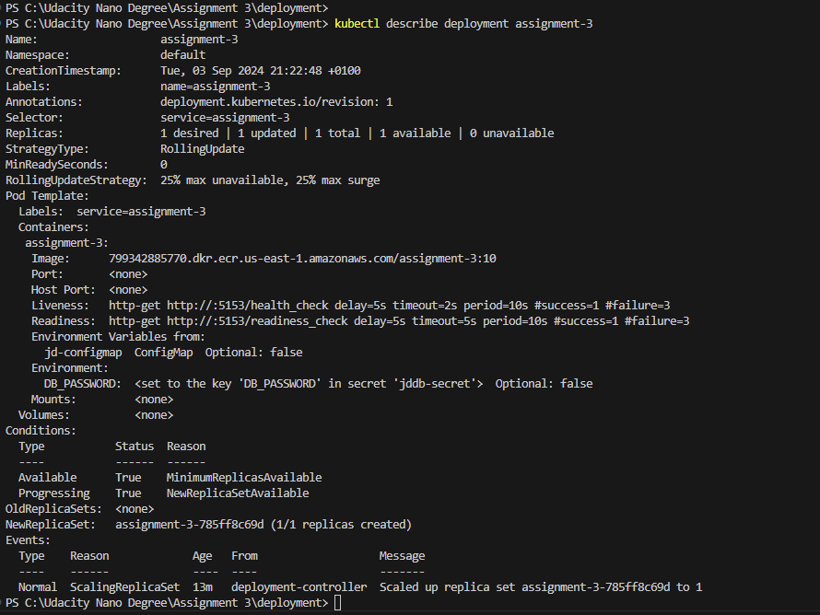

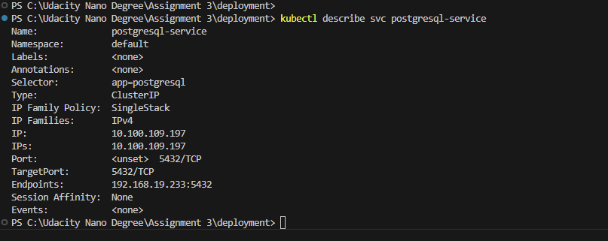

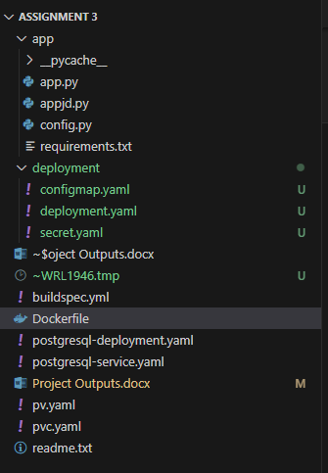

Cloudwatch Logs:

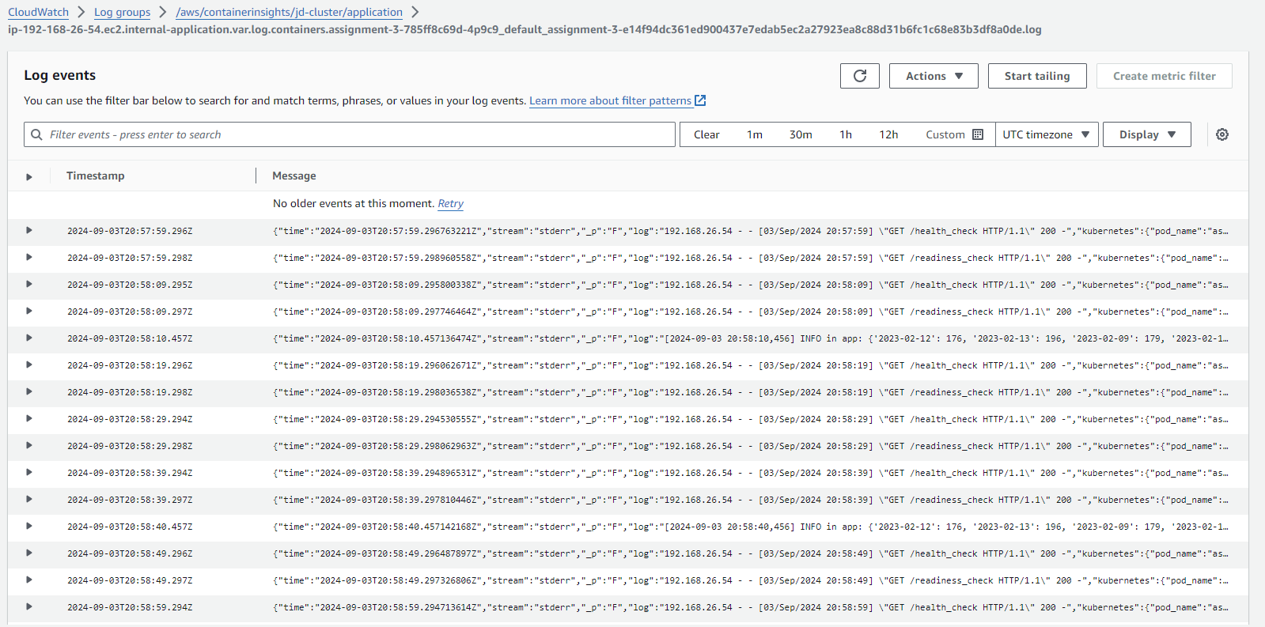

**Outputs:**

S C:\Udacity Nano Degree\Assignment 3\deployment> kubectl describe svc postgresql-service

Name: postgresql-service

Namespace: default

Labels: <none>

Annotations: <none>

Selector: app=postgresql

Type: ClusterIP

IP Family Policy: SingleStack

IP Families: IPv4

IP: 10.100.109.197

IPs: 10.100.109.197

Port: <unset> 5432/TCP

TargetPort: 5432/TCP

Endpoints: 192.168.19.233:5432

Session Affinity: None

Events: <none>

PS C:\Udacity Nano Degree\Assignment 3\deployment>

PS C:\Udacity Nano Degree\Assignment 3\deployment> kubectl describe deployment postgresql

Name: postgresql

Namespace: default

CreationTimestamp: Tue, 03 Sep 2024 20:27:43 +0100

Labels: <none>

Annotations: deployment.kubernetes.io/revision: 1

Selector: app=postgresql

Replicas: 1 desired | 1 updated | 1 total | 1 available | 0 unavailable

StrategyType: RollingUpdate

MinReadySeconds: 0

RollingUpdateStrategy: 25% max unavailable, 25% max surge

Pod Template:

Labels: app=postgresql

Containers:

postgresqlkube:

Image: postgres:latest

Port: 5432/TCP

Host Port: 0/TCP

Environment:

POSTGRES_DB: jddatabase

POSTGRES_USER: jdavidson

POSTGRES_PASSWORD: mypassword

Mounts:

/var/lib/postgresql/data from postgresql-storage (rw)

Volumes:

postgresql-storage:

Type: PersistentVolumeClaim (a reference to a PersistentVolumeClaim in the same namespace)

ClaimName: postgresql-pvc

ReadOnly: false

Conditions:

Type Status Reason

---- ------ ------

Available True MinimumReplicasAvailable

Progressing True NewReplicaSetAvailable

OldReplicaSets: <none>

NewReplicaSet: postgresql-5d67b67df5 (1/1 replicas created)

Events: <none>

PS C:\Udacity Nano Degree\Assignment 3\deployment>

PS C:\Udacity Nano Degree\Assignment 3\deployment> kubectl get svc

NAME TYPE CLUSTER-IP EXTERNAL-IP PORT(S) AGE

assignment-3 LoadBalancer 10.100.183.234 ae36fb024bc7c4424bec92aff2931da9-855240518.us-east-1.elb.amazonaws.com 5153:32500/TCP 13m

kubernetes ClusterIP 10.100.0.1 <none> 443/TCP 87m

postgresql-service ClusterIP 10.100.109.197 <none> 5432/TCP 64m

PS C:\Udacity Nano Degree\Assignment 3\deployment>

PS C:\Udacity Nano Degree\Assignment 3\deployment>

PS C:\Udacity Nano Degree\Assignment 3\deployment>

PS C:\Udacity Nano Degree\Assignment 3\deployment> kubectl describe deployment assignment-3

Name: assignment-3

Namespace: default

CreationTimestamp: Tue, 03 Sep 2024 21:22:48 +0100

Labels: name=assignment-3

Annotations: deployment.kubernetes.io/revision: 1

Selector: service=assignment-3

Replicas: 1 desired | 1 updated | 1 total | 1 available | 0 unavailable

StrategyType: RollingUpdate

MinReadySeconds: 0

RollingUpdateStrategy: 25% max unavailable, 25% max surge

Pod Template:

Labels: service=assignment-3

Containers:

assignment-3:

Image: 799342885770.dkr.ecr.us-east-1.amazonaws.com/assignment-3:10

Port: <none>

Host Port: <none>

Liveness: http-get http://:5153/health_check delay=5s timeout=2s period=10s #success=1 #failure=3

Readiness: http-get http://:5153/readiness_check delay=5s timeout=5s period=10s #success=1 #failure=3

Environment Variables from:

jd-configmap ConfigMap Optional: false

Environment:

DB_PASSWORD: <set to the key 'DB_PASSWORD' in secret 'jddb-secret'> Optional: false

Mounts: <none>

Volumes: <none>

Conditions:

Type Status Reason

---- ------ ------

Available True MinimumReplicasAvailable

Progressing True NewReplicaSetAvailable

OldReplicaSets: <none>

NewReplicaSet: assignment-3-785ff8c69d (1/1 replicas created)

Events:

Type Reason Age From Message

---- ------ ---- ---- -------

Normal ScalingReplicaSet 13m deployment-controller Scaled up replica set assignment-3-785ff8c69d to 1

PS C:\Udacity Nano Degree\Assignment 3\deployment>

PS C:\Udacity Nano Degree\Assignment 3\deployment> kubectl get pods

NAME READY STATUS RESTARTS AGE

assignment-3-785ff8c69d-4p9c9 1/1 Running 0 36s

postgresql-5d67b67df5-qx2sb 1/1 Running 0 55m

PS C:\Udacity Nano Degree\Assignment 3\deployment>

PS C:\Udacity Nano Degree\Assignment 3\deployment>

PS C:\Udacity Nano Degree\Assignment 3\deployment>

PS C:\Udacity Nano Degree\Assignment 3\deployment> kubectl get svc

NAME TYPE CLUSTER-IP EXTERNAL-IP PORT(S) AGE

assignment-3 LoadBalancer 10.100.183.234 ae36fb024bc7c4424bec92aff2931da9-855240518.us-east-1.elb.amazonaws.com 5153:32500/TCP 45s

kubernetes ClusterIP 10.100.0.1 <none> 443/TCP 75m

postgresql-service ClusterIP 10.100.109.197 <none> 5432/TCP 51m

PS C:\Udacity Nano Degree\Assignment 3\deployment>

PS C:\Udacity Nano Degree\Assignment 3\deployment>

Curl Outputs to loadbalancer address:

C:\Udacity Nano Degree>

C:\Udacity Nano Degree>curl ae36fb024bc7c4424bec92aff2931da9-855240518.us-east-1.elb.amazonaws.com:5153/api/reports/daily_usage

{"2023-02-07":40,"2023-02-08":202,"2023-02-09":179,"2023-02-10":158,"2023-02-11":146,"2023-02-12":176,"2023-02-13":196,"2023-02-14":142}

C:\Udacity Nano Degree>

C:\Udacity Nano Degree>curl ae36fb024bc7c4424bec92aff2931da9-855240518.us-east-1.elb.amazonaws.com:5153/api/reports/user_visits

{"1":{"joined_at":"2023-01-20 03:23:39.757813","visits":6},"2":{"joined_at":"2023-02-02 16:23:39.757830","visits":5},"3":{"joined_at":"2023-01-31 10:23:39.757836","visits":5},"4":{"joined_at":"2023-02-13 05:23:39.757840","visits":2},"5":{"joined_at":"2023-02-11 22:23:39.757844","visits":7},"6":{"joined_at":"2023-02-07 18:23:39.757848","visits":3},"7":{"joined_at":"2022-12-26 05:23:39.757852","visits":5},"8":{"joined_at":"2023-01-10 15:23:39.757855","visits":7},"9":{"joined_at":"2023-01-18 17:23:39.757859","visits":2},"10":{"joined_at":"2023-01-16 04:23:39.757862","visits":4},"11":{"joined_at":"2023-01-02 03:23:39.757866","visits":3},"12":{"joined_at":"2023-02-05 17:23:39.757869","visits":5},"13":{"joined_at":"2023-01-29 18:23:39.757873","visits":6},"14":{"joined_at":"2022-12-16 01:23:39.757876","visits":4},"15":{"joined_at":"2023-01-24 16:23:39.757880","visits":4},"16":{"joined_at":"2023-02-12 23:23:39.757883","visits":11},"17":{"joined_at":"2023-01-02 11:23:39.757886","visits":9},"18":{"joined_at":"2023-01-15 06:23:39.757890","visits":3},"19":{"joined_at":"2022-12-20 12:23:39.757893","visits":4},"20":{"joined_at":"2023-02-12 05:23:39.757897","visits":5},"21":{"joined_at":"2023-01-14 22:23:39.757900","visits":4},"22":{"joined_at":"2023-01-11 07:23:39.757903","visits":8},"23":{"joined_at":"2023-01-05 10:23:39.757907","visits":4},"24":{"joined_at":"2023-01-07 00:23:39.757911","visits":2},"25":{"joined_at":"2023-01-11 07:23:39.757914","visits":7},"26":{"joined_at":"2022-12-26 05:23:39.757918","visits":8},"27":{"joined_at":"2022-12-22 15:23:39.757921","visits":5},"28":{"joined_at":"2023-01-12 19:23:39.757925","visits":2},"29":{"joined_at":"2022-12-19 05:23:39.757928","visits":7},"30":{"joined_at":"2022-12-16 09:23:39.757931","visits":4},"31":{"joined_at":"2023-02-09 03:23:39.757935","visits":8},"32":{"joined_at":"2023-02-12 12:23:39.757938","visits":3},"33":{"joined_at":"2023-01-26 04:23:39.757941","visits":3},"34":{"joined_at":"2022-12-16 16:23:39.757945","visits":7},"35":{"joined_at":"2023-01-24 00:23:39.757949","visits":6},"36":{"joined_at":"2023-01-02 03:23:39.757952","visits":7},"37":{"joined_at":"2023-02-08 01:23:39.757955","visits":3},"38":{"joined_at":"2023-01-05 20:23:39.757958","visits":9},"39":{"joined_at":"2023-02-08 15:23:39.757962","visits":2},"40":{"joined_at":"2023-01-25 22:23:39.757965","visits":7},"41":{"joined_at":"2023-01-22 03:23:39.757968","visits":3},"42":{"joined_at":"2023-02-11 22:23:39.757972","visits":3},"43":{"joined_at":"2023-01-19 02:23:39.757975","visits":4},"44":{"joined_at":"2023-01-21 09:23:39.757979","visits":5},"45":{"joined_at":"2023-02-03 19:23:39.757982","visits":6},"46":{"joined_at":"2022-12-22 13:23:39.757985","visits":2},"47":{"joined_at":"2023-01-20 18:23:39.757989","visits":9},"48":{"joined_at":"2023-01-20 21:23:39.757992","visits":6},"49":{"joined_at":"2022-12-15 12:23:39.757995","visits":4},"50":{"joined_at":"2023-01-16 22:23:39.757999","visits":7},"51":{"joined_at":"2023-02-10 16:23:39.758002","visits":5},"52":{"joined_at":"2023-01-11 21:23:39.758005","visits":8},"53":{"joined_at":"2023-02-06 22:23:39.758008","visits":6},"54":{"joined_at":"2022-12-25 16:23:39.758012","visits":8},"55":{"joined_at":"2023-01-29 00:23:39.758015","visits":8},"56":{"joined_at":"2022-12-17 06:23:39.758018","visits":8},"57":{"joined_at":"2022-12-28 10:23:39.758024","visits":7},"58":{"joined_at":"2023-01-16 22:23:39.758027","visits":6},"59":{"joined_at":"2022-12-28 03:23:39.758031","visits":5},"60":{"joined_at":"2023-01-12 14:23:39.758034","visits":9},"61":{"joined_at":"2023-01-04 19:23:39.758037","visits":4},"62":{"joined_at":"2022-12-30 13:23:39.758040","visits":2},"63":{"joined_at":"2023-01-13 19:23:39.758044","visits":5},"64":{"joined_at":"2023-01-21 20:23:39.758047","visits":6},"65":{"joined_at":"2022-12-27 12:23:39.758051","visits":5},"66":{"joined_at":"2023-01-20 07:23:39.758054","visits":7},"67":{"joined_at":"2023-01-19 08:23:39.758058","visits":8},"68":{"joined_at":"2023-02-07 15:23:39.758061","visits":5},"69":{"joined_at":"2022-12-16 19:23:39.758064","visits":3},"70":{"joined_at":"2023-01-14 00:23:39.758067","visits":4},"71":{"joined_at":"2022-12-21 07:23:39.758071","visits":6},"72":{"joined_at":"2023-01-13 16:23:39.758074","visits":1},"74":{"joined_at":"2023-01-14 21:23:39.758081","visits":9},"75":{"joined_at":"2023-02-10 13:23:39.758084","visits":9},"76":{"joined_at":"2022-12-24 08:23:39.758087","visits":4},"77":{"joined_at":"2023-01-12 01:23:39.758091","visits":5},"78":{"joined_at":"2023-01-26 19:23:39.758094","visits":6},"79":{"joined_at":"2022-12-31 12:23:39.758098","visits":1},"80":{"joined_at":"2023-01-15 21:23:39.758101","visits":5},"81":{"joined_at":"2023-01-24 19:23:39.758104","visits":5},"82":{"joined_at":"2023-01-03 12:23:39.758107","visits":3},"83":{"joined_at":"2022-12-23 03:23:39.758111","visits":2},"84":{"joined_at":"2023-02-06 17:23:39.758114","visits":3},"85":{"joined_at":"2023-01-09 23:23:39.758117","visits":2},"86":{"joined_at":"2023-01-21 17:23:39.758121","visits":6},"87":{"joined_at":"2023-01-27 08:23:39.758124","visits":8},"88":{"joined_at":"2023-01-28 15:23:39.758128","visits":4},"89":{"joined_at":"2023-02-13 18:23:39.758131","visits":5},"90":{"joined_at":"2023-01-11 02:23:39.758134","visits":2},"91":{"joined_at":"2023-01-28 23:23:39.758138","visits":6},"92":{"joined_at":"2023-01-22 23:23:39.758141","visits":5},"93":{"joined_at":"2022-12-24 19:23:39.758144","visits":2},"94":{"joined_at":"2023-01-01 23:23:39.758148","visits":5},"95":{"joined_at":"2022-12-26 02:23:39.758151","visits":5},"96":{"joined_at":"2022-12-14 17:23:39.758154","visits":4},"97":{"joined_at":"2023-01-24 10:23:39.758158","visits":4},"98":{"joined_at":"2023-01-19 15:23:39.758161","visits":2},"99":{"joined_at":"2023-01-28 21:23:39.758165","visits":5},"100":{"joined_at":"2023-01-05 01:23:39.758168","visits":6},"101":{"joined_at":"2022-12-25 18:23:39.758171","visits":2},"102":{"joined_at":"2023-01-22 15:23:39.758175","visits":5},"103":{"joined_at":"2022-12-21 09:23:39.758178","visits":5},"104":{"joined_at":"2023-01-28 04:23:39.758181","visits":2},"105":{"joined_at":"2023-01-14 10:23:39.758184","visits":2},"106":{"joined_at":"2023-01-12 23:23:39.758188","visits":5},"107":{"joined_at":"2022-12-19 10:23:39.758191","visits":7},"108":{"joined_at":"2023-01-31 15:23:39.758194","visits":3},"109":{"joined_at":"2022-12-18 07:23:39.758198","visits":7},"110":{"joined_at":"2023-01-17 15:23:39.758201","visits":4},"111":{"joined_at":"2023-01-13 23:23:39.758205","visits":4},"112":{"joined_at":"2023-01-09 14:23:39.758208","visits":7},"113":{"joined_at":"2023-01-07 16:23:39.758211","visits":4},"114":{"joined_at":"2023-01-28 15:23:39.758215","visits":5},"115":{"joined_at":"2023-02-05 22:23:39.758218","visits":6},"116":{"joined_at":"2022-12-24 03:23:39.758221","visits":9},"117":{"joined_at":"2023-01-19 13:23:39.758225","visits":4},"118":{"joined_at":"2022-12-18 11:23:39.758228","visits":6},"119":{"joined_at":"2023-02-03 10:23:39.758231","visits":3},"120":{"joined_at":"2023-01-16 07:23:39.758234","visits":4},"121":{"joined_at":"2023-01-10 06:23:39.758238","visits":4},"122":{"joined_at":"2023-01-11 11:23:39.758241","visits":5},"123":{"joined_at":"2023-01-31 17:23:39.758245","visits":7},"124":{"joined_at":"2023-02-05 16:23:39.758248","visits":5},"125":{"joined_at":"2023-01-03 16:23:39.758251","visits":3},"126":{"joined_at":"2023-01-23 17:23:39.758255","visits":5},"127":{"joined_at":"2022-12-23 18:23:39.758258","visits":7},"128":{"joined_at":"2022-12-30 18:23:39.758261","visits":5},"129":{"joined_at":"2022-12-15 01:23:39.758265","visits":7},"130":{"joined_at":"2022-12-16 23:23:39.758268","visits":1},"131":{"joined_at":"2023-02-01 06:23:39.758271","visits":5},"132":{"joined_at":"2022-12-15 16:23:39.758275","visits":7},"133":{"joined_at":"2022-12-22 00:23:39.758278","visits":6},"134":{"joined_at":"2022-12-31 15:23:39.758282","visits":6},"135":{"joined_at":"2022-12-14 06:23:39.758285","visits":5},"136":{"joined_at":"2023-01-06 11:23:39.758288","visits":6},"137":{"joined_at":"2022-12-26 08:23:39.758291","visits":7},"138":{"joined_at":"2023-02-04 06:23:39.758295","visits":4},"139":{"joined_at":"2022-12-17 22:23:39.758298","visits":5},"140":{"joined_at":"2022-12-19 06:23:39.758301","visits":5},"141":{"joined_at":"2023-01-05 22:23:39.758305","visits":7},"142":{"joined_at":"2022-12-29 11:23:39.758308","visits":5},"143":{"joined_at":"2023-02-06 02:23:39.758311","visits":3},"144":{"joined_at":"2023-01-21 10:23:39.758315","visits":4},"145":{"joined_at":"2022-12-28 21:23:39.758318","visits":8},"146":{"joined_at":"2023-02-08 03:23:39.758321","visits":3},"147":{"joined_at":"2023-02-06 21:23:39.758324","visits":8},"148":{"joined_at":"2023-02-04 06:23:39.758328","visits":2},"149":{"joined_at":"2022-12-25 17:23:39.758331","visits":4},"150":{"joined_at":"2023-01-02 21:23:39.758334","visits":6},"151":{"joined_at":"2023-02-11 18:23:39.758338","visits":5},"152":{"joined_at":"2022-12-16 02:23:39.758341","visits":5},"153":{"joined_at":"2023-01-16 17:23:39.758346","visits":3},"154":{"joined_at":"2023-01-14 10:23:39.758349","visits":5},"155":{"joined_at":"2022-12-29 15:23:39.758353","visits":4},"156":{"joined_at":"2023-01-21 19:23:39.758356","visits":8},"157":{"joined_at":"2023-01-02 11:23:39.758359","visits":4},"158":{"joined_at":"2023-01-29 06:23:39.758363","visits":9},"159":{"joined_at":"2022-12-16 17:23:39.758366","visits":10},"160":{"joined_at":"2023-01-15 09:23:39.758369","visits":5},"161":{"joined_at":"2022-12-23 17:23:39.758373","visits":4},"162":{"joined_at":"2022-12-28 17:23:39.758376","visits":7},"163":{"joined_at":"2023-02-07 14:23:39.758379","visits":7},"164":{"joined_at":"2023-01-09 05:23:39.758382","visits":5},"165":{"joined_at":"2022-12-30 08:23:39.758385","visits":6},"166":{"joined_at":"2023-02-09 23:23:39.758389","visits":5},"167":{"joined_at":"2023-01-14 21:23:39.758392","visits":5},"168":{"joined_at":"2022-12-19 12:23:39.758395","visits":8},"169":{"joined_at":"2023-01-27 10:23:39.758399","visits":5},"170":{"joined_at":"2023-01-19 02:23:39.758402","visits":6},"171":{"joined_at":"2023-02-08 08:23:39.758405","visits":5},"172":{"joined_at":"2023-01-26 10:23:39.758409","visits":4},"173":{"joined_at":"2022-12-30 12:23:39.758412","visits":10},"174":{"joined_at":"2023-02-04 15:23:39.758416","visits":6},"175":{"joined_at":"2022-12-13 11:23:39.758419","visits":7},"176":{"joined_at":"2022-12-28 18:23:39.758422","visits":5},"177":{"joined_at":"2022-12-20 19:23:39.758425","visits":4},"178":{"joined_at":"2023-02-06 00:23:39.758429","visits":5},"179":{"joined_at":"2023-01-26 14:23:39.758432","visits":10},"180":{"joined_at":"2023-02-11 04:23:39.758435","visits":3},"181":{"joined_at":"2022-12-22 13:23:39.758439","visits":5},"182":{"joined_at":"2023-01-14 19:23:39.758442","visits":3},"183":{"joined_at":"2022-12-28 00:23:39.758445","visits":4},"184":{"joined_at":"2023-02-12 00:23:39.758448","visits":6},"185":{"joined_at":"2023-02-06 05:23:39.758452","visits":6},"186":{"joined_at":"2023-01-27 01:23:39.758455","visits":7},"187":{"joined_at":"2023-01-21 22:23:39.758458","visits":3},"188":{"joined_at":"2023-01-26 13:23:39.758462","visits":4},"189":{"joined_at":"2023-01-24 15:23:39.758465","visits":2},"190":{"joined_at":"2023-02-12 12:23:39.758468","visits":7},"191":{"joined_at":"2023-01-03 22:23:39.758471","visits":7},"192":{"joined_at":"2023-01-08 12:23:39.758475","visits":5},"193":{"joined_at":"2022-12-23 13:23:39.758478","visits":4},"194":{"joined_at":"2022-12-18 21:23:39.758481","visits":3},"195":{"joined_at":"2023-01-13 16:23:39.758485","visits":5},"196":{"joined_at":"2022-12-18 08:23:39.758488","visits":4},"197":{"joined_at":"2023-01-03 14:23:39.758491","visits":4},"198":{"joined_at":"2023-01-22 18:23:39.758494","visits":3},"199":{"joined_at":"2022-12-28 20:23:39.758498","visits":3},"200":{"joined_at":"2023-01-19 13:23:39.758501","visits":6},"201":{"joined_at":"2022-12-23 18:23:39.758505","visits":10},"202":{"joined_at":"2022-12-17 23:23:39.758508","visits":5},"203":{"joined_at":"2022-12-27 05:23:39.758511","visits":5},"204":{"joined_at":"2022-12-22 13:23:39.758514","visits":5},"205":{"joined_at":"2023-01-07 07:23:39.758518","visits":3},"206":{"joined_at":"2023-01-03 06:23:39.758521","visits":6},"207":{"joined_at":"2023-02-02 20:23:39.758524","visits":4},"208":{"joined_at":"2023-01-07 14:23:39.758527","visits":5},"209":{"joined_at":"2023-01-07 09:23:39.758531","visits":8},"210":{"joined_at":"2023-02-03 03:23:39.758534","visits":7},"211":{"joined_at":"2023-01-14 03:23:39.758537","visits":2},"212":{"joined_at":"2023-02-03 17:23:39.758540","visits":3},"213":{"joined_at":"2022-12-20 12:23:39.758544","visits":2},"214":{"joined_at":"2022-12-28 01:23:39.758547","visits":8},"215":{"joined_at":"2022-12-26 21:23:39.758550","visits":3},"216":{"joined_at":"2023-01-06 19:23:39.758554","visits":2},"217":{"joined_at":"2023-01-29 14:23:39.758557","visits":3},"218":{"joined_at":"2023-01-23 18:23:39.758560","visits":3},"219":{"joined_at":"2023-01-06 12:23:39.758563","visits":7},"220":{"joined_at":"2023-01-30 15:23:39.758567","visits":3},"221":{"joined_at":"2023-01-25 23:23:39.758570","visits":8},"222":{"joined_at":"2023-01-21 18:23:39.758573","visits":6},"223":{"joined_at":"2023-02-13 02:23:39.758577","visits":7},"224":{"joined_at":"2023-01-07 04:23:39.758580","visits":4},"225":{"joined_at":"2022-12-20 10:23:39.758583","visits":8},"226":{"joined_at":"2023-01-10 12:23:39.758587","visits":4},"227":{"joined_at":"2023-01-20 16:23:39.758590","visits":4},"228":{"joined_at":"2023-01-06 01:23:39.758593","visits":4},"229":{"joined_at":"2023-02-08 07:23:39.758596","visits":2},"230":{"joined_at":"2022-12-14 12:23:39.758600","visits":5},"231":{"joined_at":"2023-01-16 18:23:39.758603","visits":6},"232":{"joined_at":"2023-01-13 20:23:39.758606","visits":3},"233":{"joined_at":"2022-12-15 19:23:39.758609","visits":1},"234":{"joined_at":"2023-01-14 00:23:39.758613","visits":4},"235":{"joined_at":"2023-01-08 01:23:39.758616","visits":5},"236":{"joined_at":"2023-01-18 04:23:39.758619","visits":7},"237":{"joined_at":"2023-02-08 09:23:39.758622","visits":7},"238":{"joined_at":"2022-12-19 18:23:39.758626","visits":4},"239":{"joined_at":"2023-01-22 14:23:39.758629","visits":3},"240":{"joined_at":"2023-01-27 18:23:39.758632","visits":5},"241":{"joined_at":"2022-12-24 12:23:39.758635","visits":8},"242":{"joined_at":"2023-02-11 23:23:39.758639","visits":6},"243":{"joined_at":"2023-02-02 17:23:39.758642","visits":3},"244":{"joined_at":"2022-12-20 16:23:39.758645","visits":2},"245":{"joined_at":"2022-12-29 13:23:39.758649","visits":11},"246":{"joined_at":"2023-01-29 03:23:39.758659","visits":5},"247":{"joined_at":"2022-12-14 18:23:39.758663","visits":4},"248":{"joined_at":"2023-01-30 19:23:39.758666","visits":7},"249":{"joined_at":"2022-12-30 12:23:39.758670","visits":4},"250":{"joined_at":"2023-02-12 05:23:39.758673","visits":13},"251":{"joined_at":"2023-02-03 14:23:39.758676","visits":2},"252":{"joined_at":"2022-12-14 11:23:39.758680","visits":5},"253":{"joined_at":"2023-01-26 22:23:39.758683","visits":5},"254":{"joined_at":"2023-01-27 07:23:39.758686","visits":5},"255":{"joined_at":"2023-02-02 01:23:39.758690","visits":3},"256":{"joined_at":"2023-02-12 18:23:39.758693","visits":1},"257":{"joined_at":"2023-01-22 07:23:39.758696","visits":2},"258":{"joined_at":"2023-02-01 15:23:39.758700","visits":6},"259":{"joined_at":"2023-02-07 13:23:39.758703","visits":5},"260":{"joined_at":"2023-02-09 05:23:39.758706","visits":7},"261":{"joined_at":"2022-12-20 18:23:39.758710","visits":6},"262":{"joined_at":"2022-12-23 11:23:39.758713","visits":4},"263":{"joined_at":"2023-01-30 12:23:39.758716","visits":4},"264":{"joined_at":"2022-12-16 06:23:39.758719","visits":3},"265":{"joined_at":"2023-02-02 01:23:39.758723","visits":3},"266":{"joined_at":"2023-01-24 02:23:39.758726","visits":3},"267":{"joined_at":"2023-02-07 02:23:39.758729","visits":5},"268":{"joined_at":"2023-01-18 11:23:39.758733","visits":5},"269":{"joined_at":"2023-01-02 04:23:39.758736","visits":5},"270":{"joined_at":"2022-12-18 06:23:39.758739","visits":2},"271":{"joined_at":"2022-12-18 03:23:39.758743","visits":11},"272":{"joined_at":"2023-02-04 12:23:39.758746","visits":6},"273":{"joined_at":"2022-12-26 01:23:39.758749","visits":5},"274":{"joined_at":"2023-01-31 06:23:39.758752","visits":2},"275":{"joined_at":"2023-01-19 08:23:39.758756","visits":6},"276":{"joined_at":"2022-12-22 23:23:39.758759","visits":5},"277":{"joined_at":"2023-02-08 03:23:39.758762","visits":7},"278":{"joined_at":"2023-01-26 16:23:39.758766","visits":4},"279":{"joined_at":"2023-01-03 15:23:39.758769","visits":7},"280":{"joined_at":"2023-01-06 07:23:39.758772","visits":7},"281":{"joined_at":"2023-01-01 00:23:39.758776","visits":1},"282":{"joined_at":"2022-12-16 08:23:39.758779","visits":6},"283":{"joined_at":"2023-01-31 16:23:39.758782","visits":7},"284":{"joined_at":"2023-01-29 06:23:39.758785","visits":5},"285":{"joined_at":"2023-01-29 12:23:39.758789","visits":1},"286":{"joined_at":"2023-01-21 17:23:39.758792","visits":4},"287":{"joined_at":"2023-02-01 18:23:39.758795","visits":2},"288":{"joined_at":"2022-12-29 10:23:39.758799","visits":8},"289":{"joined_at":"2023-02-13 17:23:39.758802","visits":4},"290":{"joined_at":"2023-01-23 05:23:39.758805","visits":4},"291":{"joined_at":"2023-01-17 06:23:39.758809","visits":4},"292":{"joined_at":"2023-01-18 11:23:39.758812","visits":4},"293":{"joined_at":"2023-01-23 02:23:39.758815","visits":1},"294":{"joined_at":"2023-02-11 14:23:39.758819","visits":8},"295":{"joined_at":"2022-12-21 07:23:39.758822","visits":7},"296":{"joined_at":"2023-01-16 03:23:39.758825","visits":5},"297":{"joined_at":"2022-12-14 11:23:39.758828","visits":5},"298":{"joined_at":"2022-12-24 17:23:39.758832","visits":11},"299":{"joined_at":"2022-12-23 11:23:39.758835","visits":3},"300":{"joined_at":"2023-01-10 22:23:39.758838","visits":2},"301":{"joined_at":"2022-12-13 14:23:39.758841","visits":5},"302":{"joined_at":"2022-12-20 14:23:39.758845","visits":6},"303":{"joined_at":"2023-02-05 07:23:39.758848","visits":11},"304":{"joined_at":"2023-01-27 10:23:39.758851","visits":4},"305":{"joined_at":"2023-01-30 16:23:39.758854","visits":5},"306":{"joined_at":"2023-02-10 06:23:39.758858","visits":2},"307":{"joined_at":"2022-12-18 18:23:39.758861","visits":3},"308":{"joined_at":"2022-12-26 09:23:39.758864","visits":6},"309":{"joined_at":"2023-02-04 07:23:39.758868","visits":6},"310":{"joined_at":"2022-12-18 01:23:39.758872","visits":2},"311":{"joined_at":"2023-02-06 16:23:39.758875","visits":6},"312":{"joined_at":"2023-02-09 20:23:39.758878","visits":3},"313":{"joined_at":"2022-12-27 03:23:39.758881","visits":1},"314":{"joined_at":"2023-01-26 09:23:39.758885","visits":3},"315":{"joined_at":"2022-12-31 16:23:39.758888","visits":5},"316":{"joined_at":"2023-02-05 06:23:39.758892","visits":2},"317":{"joined_at":"2023-02-07 00:23:39.758895","visits":8},"318":{"joined_at":"2023-01-20 08:23:39.758898","visits":8},"319":{"joined_at":"2022-12-22 03:23:39.758902","visits":3},"320":{"joined_at":"2022-12-17 17:23:39.758905","visits":7},"321":{"joined_at":"2023-01-27 14:23:39.758908","visits":4},"322":{"joined_at":"2022-12-21 01:23:39.758912","visits":7},"323":{"joined_at":"2023-01-03 05:23:39.758915","visits":4},"324":{"joined_at":"2023-01-28 10:23:39.758919","visits":5},"325":{"joined_at":"2022-12-22 07:23:39.758922","visits":5},"326":{"joined_at":"2023-01-01 16:23:39.758925","visits":2},"327":{"joined_at":"2023-01-25 22:23:39.758928","visits":4},"328":{"joined_at":"2022-12-19 15:23:39.758932","visits":7},"329":{"joined_at":"2022-12-23 08:23:39.758935","visits":3},"330":{"joined_at":"2023-01-17 19:23:39.758938","visits":7},"331":{"joined_at":"2022-12-29 16:23:39.758942","visits":3},"332":{"joined_at":"2023-02-10 22:23:39.758945","visits":3},"333":{"joined_at":"2023-01-10 11:23:39.758949","visits":4},"334":{"joined_at":"2023-01-23 20:23:39.758952","visits":6},"335":{"joined_at":"2023-01-03 17:23:39.758955","visits":6},"336":{"joined_at":"2023-01-18 19:23:39.758958","visits":7},"337":{"joined_at":"2022-12-13 12:23:39.758962","visits":6},"338":{"joined_at":"2023-01-15 01:23:39.758965","visits":8},"339":{"joined_at":"2023-01-27 14:23:39.758968","visits":5},"340":{"joined_at":"2023-02-07 14:23:39.758972","visits":4},"341":{"joined_at":"2022-12-27 10:23:39.758975","visits":5},"342":{"joined_at":"2023-01-27 12:23:39.758978","visits":3},"343":{"joined_at":"2023-01-27 20:23:39.758981","visits":5},"344":{"joined_at":"2023-02-10 08:23:39.758985","visits":5},"345":{"joined_at":"2023-02-04 10:23:39.758988","visits":5},"346":{"joined_at":"2022-12-18 03:23:39.758991","visits":5},"347":{"joined_at":"2023-02-01 11:23:39.758994","visits":3},"348":{"joined_at":"2022-12-30 22:23:39.758998","visits":5},"349":{"joined_at":"2022-12-14 17:23:39.759001","visits":3},"350":{"joined_at":"2023-01-17 11:23:39.759004","visits":6},"351":{"joined_at":"2022-12-15 19:23:39.759008","visits":2},"352":{"joined_at":"2023-01-24 23:23:39.759011","visits":3},"353":{"joined_at":"2023-01-15 07:23:39.759016","visits":4},"354":{"joined_at":"2023-01-02 07:23:39.759019","visits":8},"355":{"joined_at":"2022-12-20 01:23:39.759023","visits":3},"356":{"joined_at":"2023-01-27 03:23:39.759026","visits":8},"357":{"joined_at":"2023-01-31 22:23:39.759029","visits":5},"358":{"joined_at":"2023-02-09 05:23:39.759033","visits":6},"359":{"joined_at":"2023-01-08 04:23:39.759036","visits":4},"360":{"joined_at":"2023-01-16 05:23:39.759039","visits":3},"361":{"joined_at":"2023-02-08 03:23:39.759043","visits":3},"362":{"joined_at":"2022-12-16 16:23:39.759046","visits":6},"363":{"joined_at":"2022-12-16 03:23:39.759049","visits":2},"364":{"joined_at":"2023-01-11 09:23:39.759053","visits":9},"365":{"joined_at":"2023-01-22 21:23:39.759056","visits":8},"366":{"joined_at":"2022-12-13 21:23:39.759059","visits":5},"367":{"joined_at":"2022-12-21 10:23:39.759063","visits":3},"368":{"joined_at":"2023-02-07 21:23:39.759066","visits":7},"369":{"joined_at":"2022-12-23 12:23:39.759069","visits":3},"370":{"joined_at":"2022-12-25 13:23:39.759072","visits":3},"371":{"joined_at":"2023-01-13 11:23:39.759076","visits":4},"372":{"joined_at":"2023-01-03 12:23:39.759079","visits":3},"373":{"joined_at":"2023-01-31 07:23:39.759082","visits":9},"374":{"joined_at":"2023-01-29 08:23:39.759085","visits":9},"376":{"joined_at":"2022-12-18 15:23:39.759092","visits":3},"377":{"joined_at":"2022-12-24 16:23:39.759096","visits":7},"378":{"joined_at":"2023-01-07 08:23:39.759099","visits":8},"379":{"joined_at":"2023-01-28 10:23:39.759102","visits":8},"380":{"joined_at":"2022-12-25 17:23:39.759106","visits":5},"381":{"joined_at":"2022-12-29 21:23:39.759109","visits":3},"382":{"joined_at":"2023-01-28 15:23:39.759112","visits":6},"383":{"joined_at":"2023-01-27 14:23:39.759115","visits":6},"384":{"joined_at":"2023-02-02 06:23:39.759119","visits":4},"385":{"joined_at":"2023-02-08 05:23:39.759122","visits":5},"386":{"joined_at":"2023-01-20 12:23:39.759125","visits":3},"387":{"joined_at":"2022-12-31 01:23:39.759128","visits":9},"388":{"joined_at":"2023-01-11 13:23:39.759132","visits":7},"389":{"joined_at":"2022-12-20 15:23:39.759135","visits":9},"390":{"joined_at":"2023-01-05 07:23:39.759138","visits":10},"391":{"joined_at":"2022-12-17 09:23:39.759141","visits":3},"392":{"joined_at":"2023-01-24 01:23:39.759145","visits":4},"393":{"joined_at":"2023-01-08 10:23:39.759148","visits":7},"394":{"joined_at":"2022-12-16 02:23:39.759151","visits":6},"395":{"joined_at":"2023-02-03 00:23:39.759154","visits":2},"396":{"joined_at":"2023-02-11 09:23:39.759158","visits":3},"397":{"joined_at":"2022-12-15 02:23:39.759161","visits":1},"398":{"joined_at":"2022-12-20 10:23:39.759164","visits":5},"399":{"joined_at":"2023-02-05 14:23:39.759167","visits":8},"400":{"joined_at":"2023-02-03 08:23:39.759171","visits":5},"401":{"joined_at":"2023-01-12 01:23:39.759174","visits":4},"402":{"joined_at":"2022-12-25 08:23:39.759177","visits":1},"403":{"joined_at":"2022-12-27 10:23:39.759181","visits":5},"404":{"joined_at":"2023-02-06 22:23:39.759184","visits":7},"405":{"joined_at":"2023-01-12 23:23:39.759188","visits":5},"406":{"joined_at":"2022-12-29 17:23:39.759191","visits":6},"407":{"joined_at":"2022-12-26 00:23:39.759194","visits":7},"408":{"joined_at":"2023-02-10 20:23:39.759198","visits":2},"409":{"joined_at":"2023-01-31 02:23:39.759201","visits":1},"410":{"joined_at":"2023-01-03 08:23:39.759204","visits":6},"411":{"joined_at":"2023-01-26 05:23:39.759208","visits":5},"412":{"joined_at":"2023-01-20 09:23:39.759211","visits":8},"413":{"joined_at":"2023-02-07 09:23:39.759214","visits":7},"414":{"joined_at":"2023-01-18 01:23:39.759218","visits":8},"415":{"joined_at":"2022-12-31 06:23:39.759221","visits":4},"416":{"joined_at":"2023-01-14 23:23:39.759225","visits":3},"417":{"joined_at":"2023-01-25 13:23:39.759228","visits":3},"418":{"joined_at":"2023-02-11 10:23:39.759231","visits":5},"419":{"joined_at":"2022-12-31 12:23:39.759234","visits":2},"420":{"joined_at":"2023-01-26 22:23:39.759238","visits":3},"421":{"joined_at":"2023-02-02 20:23:39.759241","visits":5},"422":{"joined_at":"2023-01-30 12:23:39.759244","visits":4},"423":{"joined_at":"2023-01-28 13:23:39.759248","visits":4},"424":{"joined_at":"2022-12-26 14:23:39.759251","visits":9},"425":{"joined_at":"2022-12-15 07:23:39.759254","visits":6},"426":{"joined_at":"2023-02-06 05:23:39.759257","visits":5},"427":{"joined_at":"2022-12-22 18:23:39.759261","visits":4},"428":{"joined_at":"2023-01-27 19:23:39.759264","visits":4},"429":{"joined_at":"2022-12-19 18:23:39.759267","visits":5},"430":{"joined_at":"2023-02-09 21:23:39.759270","visits":7},"431":{"joined_at":"2022-12-18 10:23:39.759274","visits":4},"432":{"joined_at":"2022-12-20 15:23:39.759277","visits":4},"433":{"joined_at":"2022-12-27 18:23:39.759282","visits":6},"434":{"joined_at":"2023-01-19 00:23:39.759285","visits":7},"435":{"joined_at":"2023-01-02 04:23:39.759289","visits":6},"436":{"joined_at":"2022-12-31 06:23:39.759292","visits":2},"437":{"joined_at":"2023-01-21 05:23:39.759295","visits":5},"438":{"joined_at":"2023-02-06 09:23:39.759298","visits":4},"439":{"joined_at":"2023-01-22 07:23:39.759302","visits":4},"440":{"joined_at":"2023-01-03 12:23:39.759305","visits":4},"441":{"joined_at":"2022-12-21 20:23:39.759308","visits":3},"442":{"joined_at":"2023-02-07 10:23:39.759312","visits":6},"443":{"joined_at":"2022-12-28 17:23:39.759315","visits":3},"444":{"joined_at":"2023-02-12 16:23:39.759319","visits":8},"445":{"joined_at":"2023-01-26 09:23:39.759322","visits":4},"446":{"joined_at":"2022-12-14 08:23:39.759325","visits":4},"447":{"joined_at":"2022-12-31 14:23:39.759328","visits":7},"448":{"joined_at":"2023-01-03 14:23:39.759332","visits":3},"449":{"joined_at":"2023-01-29 06:23:39.759335","visits":2},"450":{"joined_at":"2023-01-23 19:23:39.759338","visits":5},"451":{"joined_at":"2023-02-06 03:23:39.759342","visits":1},"452":{"joined_at":"2023-01-23 02:23:39.759345","visits":3},"453":{"joined_at":"2022-12-22 21:23:39.759348","visits":5},"454":{"joined_at":"2023-01-25 07:23:39.759352","visits":6},"455":{"joined_at":"2023-01-24 08:23:39.759355","visits":1},"456":{"joined_at":"2023-01-03 11:23:39.759358","visits":6},"457":{"joined_at":"2023-01-29 00:23:39.759361","visits":5},"458":{"joined_at":"2023-01-06 20:23:39.759365","visits":4},"459":{"joined_at":"2023-02-02 00:23:39.759368","visits":3},"460":{"joined_at":"2023-01-22 21:23:39.759372","visits":4},"461":{"joined_at":"2023-01-27 11:23:39.759375","visits":7},"462":{"joined_at":"2023-02-03 20:23:39.759379","visits":5},"463":{"joined_at":"2023-01-24 10:23:39.759382","visits":6},"464":{"joined_at":"2022-12-15 00:23:39.759385","visits":4},"465":{"joined_at":"2023-02-03 04:23:39.759389","visits":7},"466":{"joined_at":"2022-12-16 21:23:39.759392","visits":3},"467":{"joined_at":"2022-12-29 00:23:39.759395","visits":3},"468":{"joined_at":"2023-01-16 16:23:39.759399","visits":2},"469":{"joined_at":"2022-12-15 14:23:39.759402","visits":3},"470":{"joined_at":"2023-02-09 20:23:39.759405","visits":7},"471":{"joined_at":"2023-02-05 14:23:39.759409","visits":5},"472":{"joined_at":"2022-12-16 20:23:39.759412","visits":6},"473":{"joined_at":"2023-02-06 03:23:39.759415","visits":7},"474":{"joined_at":"2022-12-25 20:23:39.759418","visits":4},"475":{"joined_at":"2023-01-18 02:23:39.759422","visits":7},"476":{"joined_at":"2023-01-05 01:23:39.759425","visits":11},"477":{"joined_at":"2023-01-23 22:23:39.759428","visits":10},"478":{"joined_at":"2022-12-25 20:23:39.759432","visits":7},"479":{"joined_at":"2022-12-30 18:23:39.759435","visits":4},"480":{"joined_at":"2023-01-19 23:23:39.759438","visits":4},"481":{"joined_at":"2023-01-19 02:23:39.759442","visits":7},"482":{"joined_at":"2023-01-06 11:23:39.759445","visits":8},"483":{"joined_at":"2023-02-10 02:23:39.759448","visits":3},"484":{"joined_at":"2023-01-20 22:23:39.759451","visits":3},"485":{"joined_at":"2023-02-09 13:23:39.759455","visits":12},"486":{"joined_at":"2023-01-22 10:23:39.759458","visits":5},"487":{"joined_at":"2022-12-20 17:23:39.759461","visits":10},"488":{"joined_at":"2022-12-27 18:23:39.759464","visits":5},"489":{"joined_at":"2023-01-10 05:23:39.759468","visits":8},"490":{"joined_at":"2023-01-02 02:23:39.759471","visits":6},"491":{"joined_at":"2023-02-09 21:23:39.759474","visits":3},"492":{"joined_at":"2022-12-25 01:23:39.759478","visits":4},"493":{"joined_at":"2023-02-09 01:23:39.759481","visits":3},"494":{"joined_at":"2022-12-24 11:23:39.759484","visits":4},"495":{"joined_at":"2023-01-03 23:23:39.759488","visits":5},"496":{"joined_at":"2022-12-17 19:23:39.759491","visits":5},"497":{"joined_at":"2023-01-25 01:23:39.759494","visits":8},"498":{"joined_at":"2023-02-12 15:23:39.759498","visits":2},"499":{"joined_at":"2023-01-19 00:23:39.759501","visits":4},"500":{"joined_at":"2022-12-23 12:23:39.759504","visits":5}}

C:\Udacity Nano Degree>